**INXOL TECHNOLOGIES**

**GENDER CLASSIFICATION (Task 2)**

Name: Saba Amir

Roll no: 25

**ABSTRACT**

Convolutional Neural Networks (CNNs) have revolutionized the field by demonstrating exceptional proficiency in various image analysis tasks, particularly in facial recognition. This study presents a comprehensive investigation into the training of a CNN model using a diverse and extensive human face dataset. The primary objective is to develop a robust and accurate facial recognition system capable of accurately identifying individuals across a wide range of scenarios.

**Dataset:**

A comprehensive human face dataset is curated, comprising images captured under diverse conditions, including different lighting, poses, expressions, and ethnicities. Preprocessing techniques, including resizing, normalization, and noise reduction, are applied to ensure data quality.

**Model Architecture:**

The CNN architecture is thoughtfully designed, involving multiple convolutional layers for feature extraction, followed by fully connected layers for classification. The choice of activation functions, layer depths, and filter sizes is based on empirical experimentation and industry best practices.

**Evaluation:**

Metrics such as accuracy, precision, recall, and F1-score are used to measure performance. Cross-validation is employed to mitigate overfitting and validate results.

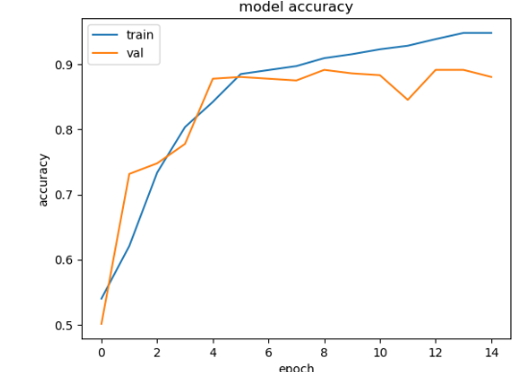

**Conclusion:**

The research contributes to the advancement of facial recognition systems by leveraging a well-curated human face dataset and a meticulously designed CNN architecture. The study highlights the pivotal role of data quality, augmentation, and transfer learning in achieving superior performance. The proposed model holds potential for applications spanning security, human-computer interaction, and beyond.